Part I
BEGIN

FUNCTION format_result(value)
IF value is a whole number THEN
RETURN value converted to integer
ELSE
RETURN value
ENDIF
END FUNCTION

DISPLAY "Enter the first number:"
INPUT num1
CONVERT num1 to a decimal number

DISPLAY "Enter the second number:"
INPUT num2
CONVERT num2 to a decimal number

SET addition = num1 + num2
SET subtraction = num1 - num2

DISPLAY "Results:"

DISPLAY "Addition:", format_result(addition)
DISPLAY "Subtraction:", format_result(subtraction)

END

def format_result(value):
return int(value) if value.is_integer() else value

# Ask the user to input two numbers
num1 = float(input("Enter the first number: "))
num2 = float(input("Enter the second number: "))

# Perform calculations
addition = num1 + num2
subtraction = num1 - num2

# Display results
print("\nResults:")
print("Addition:", format_result(addition))
print("Subtraction:", format_result(subtraction))

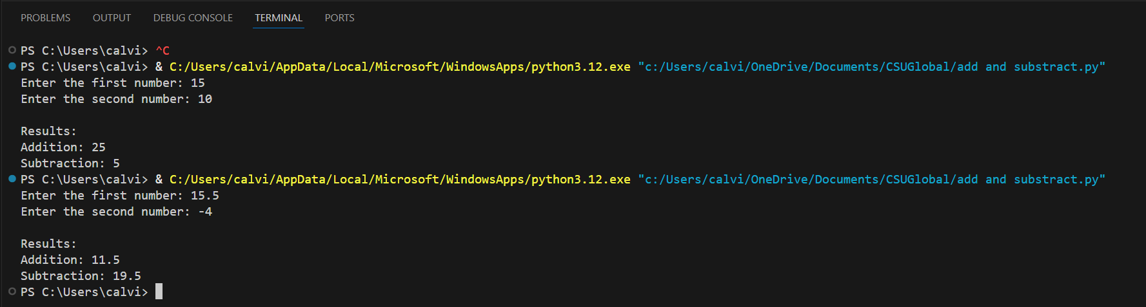

Git Repo

https://github.com/calvinscroggins-dev/csu-python-scripts

Part II

BEGIN

FUNCTION format_result(value)
IF value is a whole number THEN
RETURN value converted to integer
ELSE
RETURN value
ENDIF
END FUNCTION

DISPLAY "Enter the first number:"
INPUT num1
CONVERT num1 to a decimal number

DISPLAY "Enter the second number:"
INPUT num2
CONVERT num2 to a decimal number

SET multiplication = num1 * num2

IF num2 is not equal to 0 THEN
SET division = num1 / num2
ELSE
SET division = NULL
ENDIF

DISPLAY "Results:"

DISPLAY "Multiplication:", format_result(multiplication)

IF division is NULL THEN
DISPLAY "Division: Cannot divide by zero"
ELSE
DISPLAY "Division:", format_result(division)
ENDIF

END

def format_result(value):
return int(value) if value.is_integer() else value

# Ask the user to input two numbers
num1 = float(input("Enter the first number: "))
num2 = float(input("Enter the second number: "))

# Perform calculations
multiplication = num1 * num2

# Handle division safely
if num2 != 0:
division = num1 / num2
else:
division = None

# Display results
print("\nResults:")
print("Multiplication:", format_result(multiplication))

if division is None:
print("Division: Cannot divide by zero")
else:
print("Division:", format_result(division))

